THE DECEMBERISTS TO RELEASE NEW ALBUM I’LL BE YOUR GIRL OUT MARCH 16 ON ROUGH TRADE RECORDS

FIRST SINGLE “SEVERED” OUT NOW

ACCLAIMED PORTLAND BAND EXPLORE A NEW SOUND
TO SPARK A NEW CREATIVE PATH ON THEIR EIGHTH STUDIO ALBUM PRODUCED BY JOHN CONGLETON

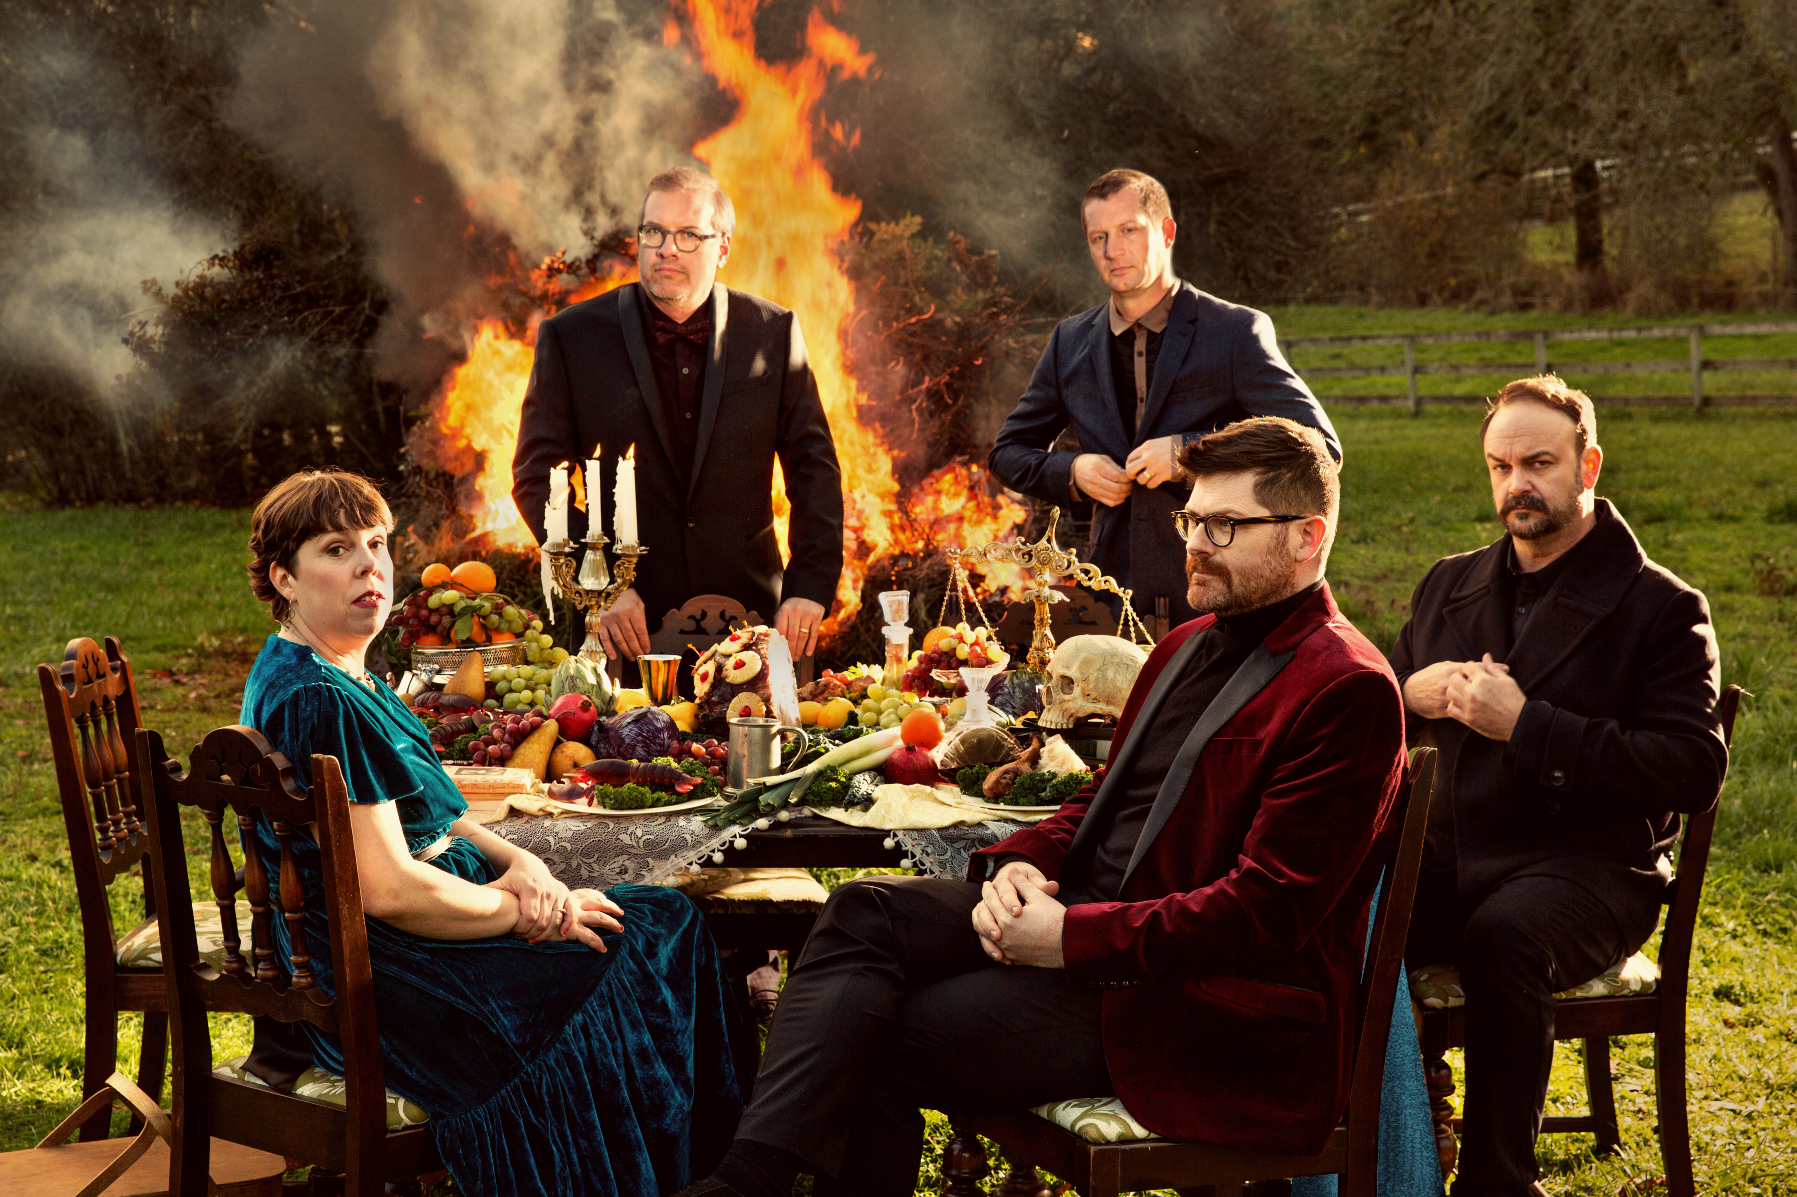
(photo credit: Holly Andres – click to download Hi Res photo)

The Decemberists explore a new sound with a new producer on their inspired eighth studio album I’ll Be Your Girl, which will be released March 16 on Rough Trade Records. The acclaimed Portland, Oregon-based band worked with producer John Congleton (St. Vincent, Lana del Ray) and embraced influences such as Roxy Music and New Order to spark a new creative path, as can be heard on the synth-driven lead single “Severed,” which is available today to stream or download
.
“When you’ve been a band for 17 years, inevitably there are habits you fall into,” says Colin Meloy. “So our ambition this time was really just to get out of our comfort zone. That’s what prompted working with a different producer and using a different studio. We wanted to free ourselves from old patterns and give ourselves permission to try something different.”

With I’ll Be Your Girl, the Decemberists—lead vocalist and guitarist Meloy, guitarist Chris Funk, keyboardist Jenny Conlee, bassist Nate Query, and drummer John Moen—explore new approaches to making music and broaden their sonic range. It’s the group’s follow-up to 2015’s What a Terrible World, What a Beautiful World (which charted in the US Top Ten), though in the time since, they have released the EP Florasongs; a 10th anniversary limited edition vinyl box set of their 2006 album The Crane Wife; their own crowd-funded board game Illimat; The Queen of Hearts, a GRAMMY-nominated collaboration with Olivia Chaney under the name Offa Rex; and “Ben Franklin’s Song,” the first of Lin-Manuel Miranda’s monthly “Hamildrops” of bonus material from Hamilton; as well as launching Travelers’ Rest, an annual two-day musical festival of their own curation in Missoula, Montana.

As busy as they have been, the band felt a need to shake things up. “On the last record,” says Meloy, “there were moments when I thought I was making familiar choices. I tried to be mindful in the songwriting process of challenging myself and being a little more critical. The idea was, how can we make unfamiliar choices, turn off the light a little and grope around in the dark a bit?”

Previous Decemberists’ records like The Hazards of Love or The Crane Wife have been structured around thematic or musical concepts, though Meloy maintains that ultimately, it’s always “our frame of mind that ties them together.” This time, he says, the songs share a mood that’s steeped in our current times and condition—“exuberant nihilism, an apocalyptic dance party was what we envisioned.”

“We were talking about music and our references,” says Meloy. “It kept coming back to Roxy Music and early glam, and we dove in with that in mind. The Decemberists are a record-collectors’ band, we’re all fans and scholars of music, so there a lot of touch points that we all get, but they don’t always come through. So we were trying to embrace that Bryan Ferry aspect, that kind of set the tone.”

The approach the Decemberists pursued on I’ll Be Your Girl also allowed for a new sense of contribution and involvement from the other band members. “Since we were going to mix it up, everybody felt like they had more of a voice,” says Meloy. Highlighting the input of Chris Funk and Jenny Conlee, Meloy mentions “Severed” as a significant team effort. “That was written as a punk song, but wasn’t really working,” he says. “Jenny set this arpeggio throughout it, and it became like an early New Order song. And I had forgotten that when we made the demo, I also started a file to turn it into more of a Depeche Mode song—I actually wanted it to be a synth song all along.”

I’ll Be Your Girl is the sound of a veteran band finding new inspiration, a unit unafraid of challenging itself to re-connect with its creativity. “Making music is an infinite choose-your-own-adventure,” says Meloy (who is also, of course, the author of a series of best-selling children’s books), “and when you go down one path, the other paths get sealed off. So every time we could, we said, ‘If this is what our impulses would tell us to do, let’s try to imagine it in a different way.’”

The track listing for I’ll Be Your Girl is as follows:
1. Once In My Life
2. Cutting Stone
3. Severed
4. Starwatcher
5. Tripping Along
6. Your Ghost
7. Everything Is Awful
8. Sucker’s Prayer
9. We All Die Young
10. Rusalka, Rusalka / The Wild Rushes
11. I’ll Be Your Girl

I’ll Be Your Girl will be released on limited edition 180gm white vinyl, 180gm vinyl, CD, download and mysterious deluxe edition box dubbed Ill Be Your Girl: The Exploded Version, for which details will be revealed shortly

Pre-Order From The Rough Trade Records Webstore Here: https://store.roughtraderecords.com/products/the-decemberists-ill-be-your-girl

* * *

The band has also announced the first dates of their 2018 Your Girl / Your Ghost World Tour, which kicks off March 22. The Decemberists have also announced the second coming of Travelers’ Rest, a two-day festival curated by the band that will take place August 4-5 at the Big Sky Brewing Company Amphitheatre in Missoula, Montana. See below for a full list of tour dates and visit decemberists.com for more ticket information. Further dates will be announced shortly

YOUR GIRL / YOUR GHOST WORLD TOUR 2018
March 22 – Fox Theatre – Pomona, CA
March 23 – Arlington Theatre – Santa Barbara, CA
March 24 – Innings Fest – Tempe, AZ
April 6 – Palace Theatre – St. Paul, MN
April 8 – Riverside Theatre – Milwaukee, WI
April 10 – Chicago Theatre – Chicago, IL
April 13-14 – Ryman Auditorium – Nashville, TN
April 15 – Coca- Cola Roxy Theatre – Atlanta, GA
April 16 – North Charleston Performing Arts Center – Charleston, SC
April 18 – Charlotte Metro Credit Union Amphiteatre – Charlotte, NC
April 19 – Durham Performing Arts Center – Durham, NC
April 20 – The National – Richmond, VA
April 21 – The Anthem – Washington DC
April 23 – Smith Opera House – Geneva, NY
April 24 – Agora Theatre – Cleveland, OH
April 25 – Peabody Opera House – St. Louis, MO
May 22 – Red Rocks Amphitheatre – Morrison, CO +
May 23 – Uptown Theatre – Kansas City, MO
May 25 – Hill Auditorium – Ann Arbor, MI
May 26 – Art Park – Lewiston, NY
May 27 – Boston Calling – Boston, MA
May 28 – MTELUS – Montreal, QC
May 30 – Sony Center For The Performing Arts – Toronto, ON
May 31 – Benedum Center – Pittsburgh, PA
June 2 – Murat Theater at Old National Centre – Indianapolis, IN
June 5 – Iroquois Amphitheater – Louisville, KY
June 7 – Mann Center For The Performing Arts – Philadelphia, PA ^
June 8 – College Street Music Hall – New Haven, CT ^
June 9 – The Green at Shelburne Museum – Burlington, VT ^
June 10 – State Theatre – Portland, ME ^
June 13 – BRIC Celebrate Brooklyn at Prospect Park Bandstand – Brooklyn, NY ^
June 15 – MASS MoCA – North Adams, MA
June 21 – Paramount Theatre – Seattle, WA ^
June 22-23 – Edgefield – Portland, OR ^
August 4-5 – Travelers’ Rest – Missoula, MT

^ with M. Ward
+ with Whitney

For more information contact Ben Ayres at Rough Trade Records
(p) 02088755190 / 07917062669 / benayres@roughtraderecords.com

